

Foundations of Programming
Assignment No. : 11

PROBLEM STATEMENT:
Write a program in C to accept a number from the user and compute the following:
- Square root of the number
- Square of the number
- Cube of the number
- Check whether the number is prime
- Factorial of the number
- Prime factors of the number

OBJECTIVE:
• To understand the use of mathematical operations in C.
• To implement loops and conditional statements
. • To perform number-based computations.
• To enhance logical thinking using menu-driven programs.

THEORY:
Numbers and their mathematical properties play a vital role in programming. Operations such as square, cube, and square root are basic mathematical computations. Prime number checking involves verifying whether a number has exactly two divisors. Factorial is calculated by multiplying a sequence of integers. Prime factorization breaks a number into its prime components. In C programming, these operations can be efficiently implemented using loops, conditional statements, and mathematical functions.

PLATFORM:
Linux

ALGORITHM:
- Start
- Declare variables num, choice, i, fact, and flag
- Accept an integer number num from the user
- Display a menu of operations:
- Square Root
- Square
- Cube
- Check Prime
- Factorial
- Prime Factors
- Accept the user’s choice
- Use a switch–case statement based on the selected choice
- If choice is:
- Square Root:
  - Check if number is negative
  - If not negative, calculate square root using sqrt()
- Square:
  - Calculate num × num
- Cube:
  - Calculate num × num × num
- Check Prime:
  - Check divisibility from 2 to num / 2
  - If divisible, number is not prime
- Factorial:
  - If number is non-negative, calculate factorial using loop
- Prime Factors:
  - Divide the number by all possible prime numbers starting from 2
- Display the result of the selected operation
- Stop

C PROGRAM:
#include <stdio.h>
#include <math.h>

int main()
{
int num, choice, i, flag;
long long fact;

printf("\nMENU");
printf("\n1. Square Root");
printf("\n2. Square");
printf("\n3. Cube");
printf("\n4. Check Prime");
printf("\n5. Factorial");
printf("\n6. Prime Factors");
printf("\nEnter your choice: ");
scanf("%d", &choice);

printf("Enter the number: ");
scanf("%d", &num);

switch (choice)
{
case 1:
if (num < 0)
printf("Square root not possible");
else
printf("Square Root = %.2f", sqrt(num));
break;

case 2:
printf("Square = %d", num * num);
break;

case 3:
printf("Cube = %d", num * num * num);
break;

case 4:
flag = 1;
if (num <= 1)
flag = 0;

for (i = 2; i <= num / 2; i++)
{
if (num % i == 0)
{
flag = 0;
break;
}
}

if (flag)
printf("Number is Prime");
else
printf("Number is Not Prime");
break;

case 5:
if (num < 0)
printf("Factorial not defined");
else
{
fact = 1;
for (i = 1; i <= num; i++)
fact *= i;
printf("Factorial = %lld", fact);
}
break;

case 6: // Prime Factors
if (num <= 1)
printf("Prime factors not defined");
else
{
printf("Prime Factors: ");
for (i = 2; i <= num; i++)
{
while (num % i == 0)
{
printf("%d ", i);
num /= i;
}
}
}
break;

default:
printf("Invalid choice");
}

return 0;
}

FLOWCHART:

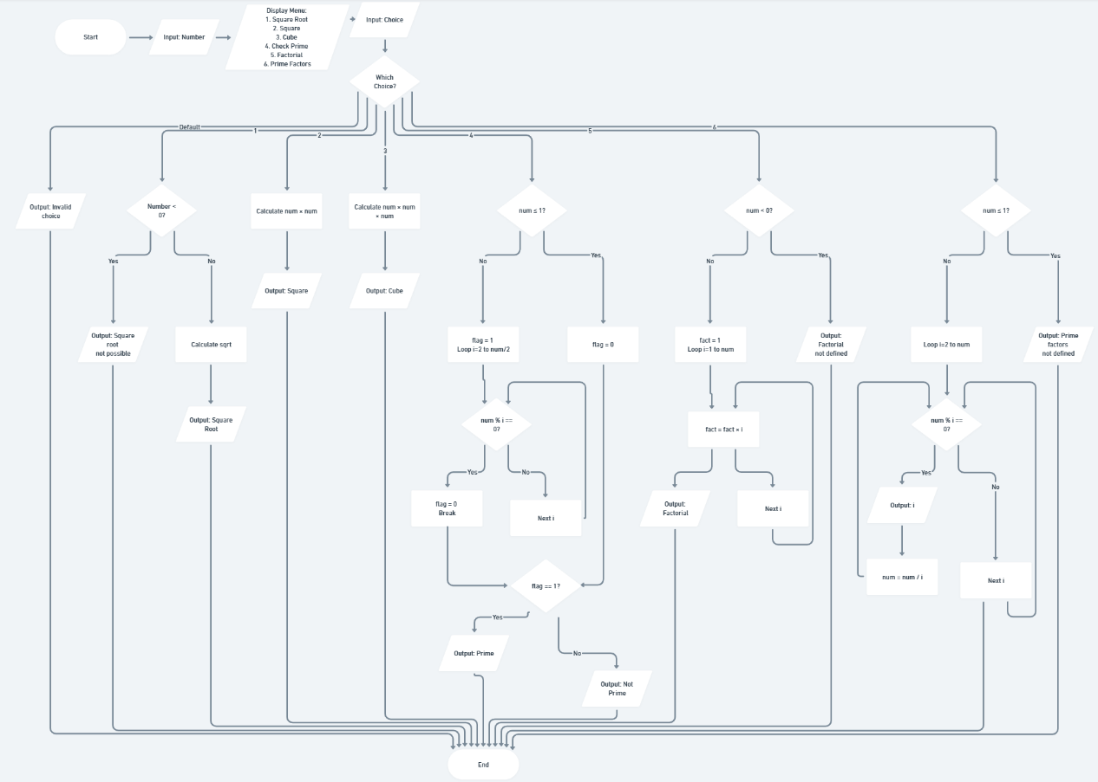

INPUT/OUTPUT:
The user enters an integer number and selects an operation from the menu.
Example Input: Number: 5 Choice: 3

Example Output:
The program displays the result based on the selected operation.
Example Output: Cube = 125

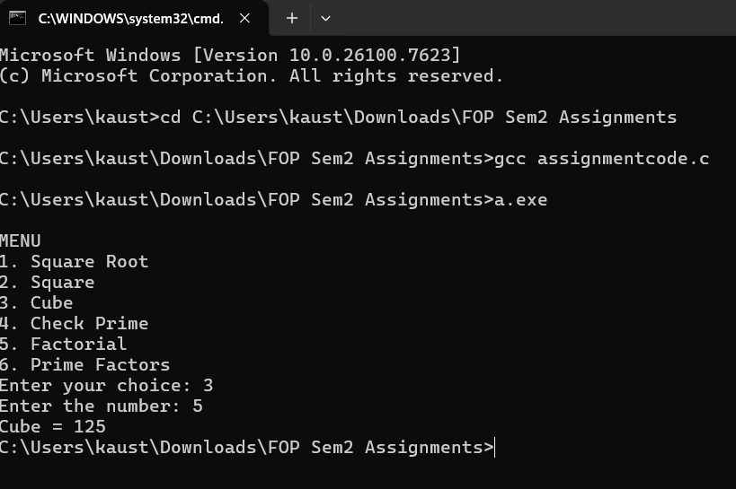

CONCLUSION:
Thus, the program to perform various mathematical operations on a number was successfully implemented using C programming. This program demonstrates the use of loops, conditional statements, switch-case, and mathematical functions.

